installation & fabrication

engineers **(Pvt) Ltd.**

**Head Office: 100-K, Gulberg-III, Lahore**

**Work: REHMAN INDUSRIAL ESTATE**

**Gaju Matta, 21 / 22 K.M. Ferozepur road P.O Kahna-Nau Lahore Phone: 5270894-5272194 Fax: (042) 5270895**

**TO WHOM IT MAY CONCERN**

It is certified that Mr. <Name> S/o <fname> bearing N.I.C. Number <CNIC> has working with us as <Designation> from <From> to <To>.

He was a hard working and efficient worker. His performance remained entirely satisfactory on his assigned jobs.

He is leaving his organization on his own accord for better prospects, we wish him success in his future life.

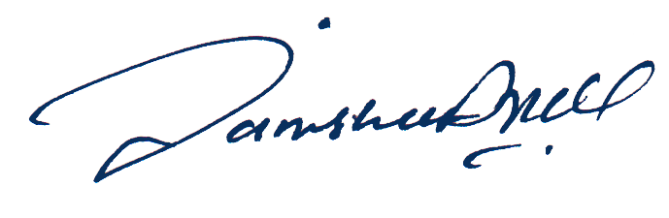

**Abdul Rauf Chief Executive**